FAKE REVIEWS DETECTION USING MACHINE LEARNING AND DEEP LEARNING ALGORITHMS

ABSTRACT

In the age of technology, a tremendous amount of data is being generated online every day. However, an unprecedented amount of the data flooded on the Internet is Fake Reviews, which is generated to attract the customers or audience, to influence beliefs and decisions of people, to increase the revenue generated by clicking and to affect major events such as political elections.

Fake reviews means incorporating information that leads people to the wrong paths. It can have real-world adverse effects that aim to intentionally deceive, gain attention, manipulate public opinion, or damage reputation. It is necessary to detect Fake reviews mainly for media outlets to have the ability to attract viewers to their website to generate online advertising revenue. This project develops a Deep learning model using Tensor flow and uses this model to detect whether the reviews is Fake reviews or not. It uses Fake Reviews_news_dataset, which contains reviews text and corresponding label (FAKE reviews or REAL).

Society and individuals are negatively influenced both politically and socially by the
widespread increase of Fake reviews either way generated by humans or machines. In the era of social networks, the quick rotation of reviews makes it challenging to evaluate its reliability promptly. Therefore, automated Fake reviews detection tools have become a crucial requirement. To address the aforementioned issue, K-Nearest Neighbor and a Support Vector Machine based classification is used here. This project proposed a Fake reviews stance detection model based on the headline and the body of the reviews irrespective of the previous studies which only considered the individual sentences or phrases. In addition, convolutional neural network based classification is also carried out. Python 3.11 is used for project development.

CONTENTS
CHAPTER NO. | TITLE | PAGE NO.
 | ABSTRACT
1 | INTRODUCTION
 | 1.1 Objectives
 | 1.2 About The Project
2 | LITERATURE SURVEY
 | 2.1 Related Work
3 | SYSTEM ANALYSIS
 | 3.1 Existing System
 | 3.2 Drawbacks of Existing System
 | 3.3 Proposed System
 | 3.4 Advantages of Proposed System
 | 3.5 Feasibility Study
 | 3.5.1 Economical Feasibility
 | 3.5.2 Operational Feasibility
 | 3.5.1 Technical Feasibility
4 | System Specification
 | 4.1 Hardware Requirements
 | 4.2 Software Requirements
5 | SOFTWARE DESCRIPTION
 | 4.1 Front End
 | 4.2 Back End
6 | PROJECT DESCRIPTION
 | 6.1 Problem Definition
 | 6.2 Overview of the project
 | 6.3 Module Description
 | 6.4 Input Design
 | 6.5 Output Design
 | 6.6 System Flow Diagram
 | 6.7 Use Case Diagram
7 | SYSTEM TESTING
8 | SYSTEM IMPLEMENTATION
9 | CONCLUSION AND FUTURE ENHANCEMENT
10 | BIBLIOGRAPHY
 | 10.1 Book References
 | 10.2 Web References
 | 10.3 Journal References
 | APPENDIX
 | - Sample Screens
 | - Source Code

CHAPTER 1

INTRODUCTION

1.1 OBJECTIVES

The main objectives of the project are

- To collect reviews dataset from web site (kaggle) website.
- To preprocess the dataset such as removing Unicode characters.
- To split the total reviews content into paragraphs.
- To check with the new review content and check with dataset paragraphs for similarity.
- To apply KNN that checks the reviews as real or Fake reviews from the help of dataset contents.

1.2 ABOUT THE PROJECT

An unprecedented amount of the data flooded on the Internet is Fake reviews news, which is generated to attract the audience, to influence beliefs and decisions of people, to increase the revenue generated by clicking, and to affect major events such as political elections. Readers are misguided by deliberately spreading false information. Obtaining and spreading information through social media platforms has become extremely trouble-free, which makes it difficult and nontrivial to detect based merely on the content of news.
For example, some reports illustrate that Russia has created Fake reviews accounts and social bots to spread Fake reviews news. According to a research poll, 64% of US citizens reported that Fake reviews has caused a ‘‘great deal of confusion’’ about the factual content of reported events. On top of that, large-scale false information cascade has increasingly harmful consequences in the field of business, marketing, and stock-share.
For instance, in 2013, 130 billion dollars were wiped out in stock value
after a false reviews spread on twitter that Barack Obama was injured in an explosion. In the US presidential campaign of 2016, Fake reviews has been accused of being foremost contributing factor of the increasing political polarization and partisan conflict as well as affecting the outcome.
This project develops a Deep learning model using Tensor flow and uses this model to detect whether the reviews is Fake reviews or not. It uses Fake Reviews_news_dataset, which contains reviews text and corresponding label (FAKE reviews or REAL). An architecture named Support Vector Machine is used here. This project proposed a Fake reviews stance detection model based on the headline and the body of the reviews irrespective of the previous studies which only considered the individual sentences or phrases.

CHAPTER 2

LITERATURE SURVEY

2.1 RELATED WORK

2.1.1 FINDING OPINION MANIPULATION TROLLS IN reviews COMMUNITY FORUMS
AUTHORS
Todor Mihaylov
Georgi D. Georgiev
Preslav Nakov

In this paper [1] the authors stated that the emergence of user forums in electronic reviews media has given rise to the proliferation of opinion manipulation trolls. Finding such trolls automatically is a hard task, as there is no easy way to recognize or even to define what they are; this also makes it hard to get training and testing data. They solved this issue: they assumed that a user who is called a troll by several people is likely to be one. They experimented with different variations of this definition, and in each case they showed that they can train a classifier to distinguish a likely troll from a non-troll with very high accuracy, 82–95%, thanks to our rich feature set.

With the rise of social media, it became normal for people to read and follow other users’ opinion. This created the opportunity for corporations, governments and others to distribute rumors, misinformation, speculation and to use other dishonest practices to manipulate user opinion (Derczynski and Bontcheva, 2014a). They could consistently
use trolls (Cambria et al., 2010), write Fake reviews posts and comments in public forums, thus making veracity one of the challenges in digital social networking (Derczynski and Bontcheva, 2014b).

The practice of using opinion manipulation trolls has been reality since the rise of Internet and community forums. It has been shown that user opinions about products, companies and politics can be influenced by posts by other users in online forums and social networks (Dellarocas, 2006). This makes it easy for companies and political parties to gain popularity by paying for “reputation management” to people or companies that write in discussion forums and social networks Fake reviews opinions from Fake reviews profiles.
In Europe, the problem has emerged in the context of the crisis in Ukraine. There have been a number of publications in reviews media describing the behavior of organized trolls that try to manipulate other users’ opinion. Still, it is hard for forum administrators to block them as trolls try not to violate the forum rules.

They crawled the largest Internet community forum of a Bulgarian media, that of Dnevnik.bg, a daily newspaper that requires users to be signed in order to comment, which makes it easy to track them. The platform allows users to comment on news, to reply to other users’ comments and to vote on them with thumbs up or thumbs down. In the forum, the official language is Bulgarian and all comments are written in Bulgarian. Each publication has a category, a subcategory, and a list of manually selected tags (keywords). We crawled all publications in the Bulgaria, Europe, and World categories, which turned out to be mostly about politics, for the period 01-Jan-2013 to 01-Apr-2015, together with the comments and the corresponding user profiles.

They considered as trolls users who were called such by at least n distinct users, and non-trolls if they have never been called so. Requiring that a user should have at least 100 comments in order to be interesting for our experiments left us with 317 trolls and 964 non-trolls.

Their features are motivated by several publications about troll behavior mentioned above. For each user, we extract statistics such as number of comments posted, number of days in the forum, number of days with at least one comment, and number of publications commented on. All (other) features are scaled with respect to these statistics, which makes it possible to handle users that registered only recently. Our features can be divided in the following groups:

Vote-based features. They calculated the number of comments with positive and negative votes for each user. This is useful as they assumed that non-trolls are likely to disagree with trolls, and to give them negative votes. They used the sum from all comments as a feature. They also counted separately the comments with high, low and medium
positive to negative ratio. Here are some example features: the number of comments where
(positive/negative) < 0.25, and the number of comments where (positive/negative) < 0.50.
Comment-to-publication similarity. These features measure the similarity between comments and publications. We use cosine and TF.IDF-weighted vectors for the comment and for the publication. The idea is that trolls might try to change or blurr the topic of the publication if it differs from his/her views or agenda.

Comment order-based features. They counted how many user comments the user has among the first k. The idea is that trolls might try to be among the first to comment to achieve higher impact.

Top loved/hated comments. They calculated the number of times the user’s comments were among the top 1, 3, 5, 10 most loved/hated comments in some thread. The idea is that in the comment thread below many publications there are some trolls that oppose all other users, and usually their comments are among the most hated.

Comment replies-based features. These are features that count how many user comments are replies to other comments, how many are replies to replies, and so on. The assumption here is that trolls try to post the most comments and want to dominate the conversation, especially when defending a specific cause. They further generated complex features that mix comment reply features and vote counts-based features, thus generating even more features that model the relationship between replies and user agreement/disagreement.

They concluded that they have presented experiments in trying to distinguish trolls vs. non-trolls in reviews community forums. They have experimented with a large number of features, both scaled and non-scaled, and they have achieved very strong overall results using statistics such as number of comments, of positive and negative votes, of posting replies, activity over time, etc. The nature of their features means
that our troll detection works best for “elder trolls” with at least 100 comments in the forum. In future work, they plan to add content features such as key words, topics, named entities, part of speech, and named entities, which should help detect “fresh”
trolls. Our ultimate objective is to be able to find and expose paid opinion manipulation trolls.

2.1.2 EXPOSING PAID OPINION MANIPULATION TROLLS
AUTHORS
Todor Mihaylov,
Ivan Koychev
Georgi D. Georgiev
Preslav Nakov

In this paper [2] the authors stated that recently, Web forums have been invaded by opinion manipulation trolls. Some trolls try to influence the other users driven by their own convictions, while in other cases they can be organized and paid, e.g., by a political party or a PR agency that gives them specific instructions what to write. Finding paid trolls automatically
using machine learning is a hard task, as there is no enough training data to train a classifier; yet some test data is possible to obtain, as these trolls are sometimes caught and widely exposed. In this paper, they solved the training data problem by assuming that a user who is called a troll by several different people is likely to be such, and one who has never been called a troll is unlikely to be such.
They compared the profiles of (i) paid trolls vs. (ii) “mentioned” trolls vs. (iii) non-trolls, and we further show that a classifier trained to distinguish (ii) from (iii) does quite well also
at telling apart (i) from (iii). During the 2013-2014 Bulgarian protests against the Oresharski cabinet, social networks and reviews community forums became the main “battle grounds” between supporters and opponents of the government. In that period, there was notable censorship in the media, and many people who lived outside the capital did not really know what was actually happening.

Moreover, there was a very notable presence of government supporters in Web forums. In series of leaked documents in the independent Bulgarian media Bivol, it was alleged that the ruling Socialist party was paying Internet trolls with EU Parliament money. The Bivol’s leaked documents revealed for the first time such a practice by a political party despite the problem with opinion manipulation being generally notable across Eastern Europe.

The reputation management documents described the following services:“Monthly posting online of 250 comments by virtual users with varied, typical and evolving profiles from different (non-recurring) IP addresses to inform, promote, balance or counteract. The intensity of the provided online presence will be adequately distributed and will correspond to the political situation in the country.”

The practice of using Internet trolls for opinion manipulation has been reality since the rise of Internet and community forums. It has been shown that user opinions about products, companies and politics can be influenced by opinions posted by other online users (Dellarocas, 2006). This makes it easy for companies and political parties to gain popularity by paying for “reputation management” to people that write in discussion forums and social networks Fake reviews opinions from Fake reviews profiles. Yet, over time, forum users developed sensitivity about trolls, and started publicly exposing them. They concluded that they have presented experiments in trying to distinguish paid opinion manipulation trolls vs. non-trolls in Internet forums. As they did not have enough known paid trolls, for training we used “mentioned” trolls, assuming that a user who is called a troll by several different people is likely to be one, while one who has never been called a troll is unlikely to be such.
They compared the profiles of (i) paid trolls vs. (ii) “mentioned” trolls vs. (iii) non-trolls, and they have shown that a classifier trained to distinguish (ii) from (iii) does quite well also at telling apart (i) from (iii). Their further analysis has shown that the most important features were the number of comments, of positive and of negative votes, of posted replies, and the time of commenting. Overall, paid trolls looked roughly like the “mentioned” trolls, except that they were posting most of their comments on working days and during working hours. Unfortunately, our features only worked well for trolls with high number of posts.

2.1.3 HUNTING FOR TROLL COMMENTS IN reviews COMMUNITY FORUMS
AUTHORS
Todor Mihaylov
Preslav Nakov
In this paper [3] the authors stated that there are different definitions of what a troll is. Certainly, a troll can be somebody who teases people to make them angry, or somebody who offends people, or somebody who wants to dominate any single discussion, or somebody who tries to manipulate people’s opinion (sometimes for money), etc. The last definition is the one that dominates the public discourse in Bulgaria and Eastern Europe, and this is their focus in this paper. In their work, they examined two types of opinion manipulation trolls: paid trolls
that have been revealed from leaked “reputation management contracts” and “mentioned trolls” that have been called such by several different people. They showed that these definitions are sensible: they built two classifiers that can distinguish a post by such a paid troll from one by a non-troll with 81-82% accuracy; the same classifier achieves 81-82% accuracy on so called
mentioned troll vs. non-troll posts.

The practice of using Internet trolls for opinion manipulation has been reality since the rise of Internet and community forums. It has been shown that user opinions about products, companies and politics can be influenced by opinions posted by other online users in online forums and social networks (Dellarocas, 2006). This makes it easy for companies and political parties to gain popularity by paying for “reputation management” to people that write in discussion forums and social networks Fake reviews opinions from Fake reviews profiles.

Opinion manipulation campaigns are often launched using “personal management software” that allows a user to open multiple accounts and to appear like several different people. Over time, some forum users developed sensitivity about trolls, and started publicly exposing them.

Yet, it is hard for forum administrators to block them as trolls try formally not to violate the forum rules. In their work, they examined two types of opinion manipulation trolls: paid trolls that have been revealed from leaked “reputation management contracts” and “mentioned trolls” that have been called such by several different people.

They concluded that they have presented experiments in predicting whether a comment is written by a troll or not, where they defined troll as somebody who was called such by other people. They have shown that this is a useful definition and that comments by mentioned trolls are similar to such by confirmed paid trolls.

2.1.4 FROM CLICKBAIT TO FAKE reviews DETECTION: AN APPROACH BASED ON DETECTING THE STANCE OF HEADLINES TO ARTICLES
AUTHORS
Peter Bourgonje,
Julian Moreno Schneider,
Georg Rehm

In this paper [4] the authors stated that they presented a system for the detection of
the stance of headlines with regard to their corresponding article bodies. The approach can be applied in Fake reviews news, especially clickbait detection scenarios. The component is part of a larger platform for the curation of digital content; they considered veracity and relevancy an increasingly important part of curating online information. They want to contribute to the
debate on how to deal with Fake reviews and related online phenomena with technological means, by providing means to separate related from unrelated headlines and further classifying the related headlines.

On a publicly available data set annotated for the stance of headlines with regard to their corresponding article bodies, they achieved a (weighted) accuracy score of 89.59.

With the advent of social media and its increasingly important role as a provider and amplifier of news, basically anyone, anywhere, can produce and help circulate content for other people to read. Traditional barriers to publishing content (like a press to print newspapers or broadcasting time for radio or television) have disappeared, and with this, at least part of traditional quality control procedures had disappeared as well.

Basic journalistic principles like source verification, fact checking and accountability can be easily bypassed or simply ignored by individuals or organisations publishing content on Twitter, Facebook or other social networks.

The impact of this situation is illustrated by the predominance of terms like “trolls”, “Fake reviews news”, “post-truth media” and “alternative facts”. There is evidence that these developments and their effects are not harmless but can have a significant impact on real-world events, which is illustrated by a description of the role of social media in the 2016 US presidential election by (Allcott and Gentzkow, 2017), and by a study on the effectiveness and debunking strategies of
rumours surrounding the Affordable Care Act by (Berinsky, 2017).

While the cause of this situation may have its roots in many different aspects of modern society, and hence needs to be approached from several different angles, they aimed to make a contribution from the angle of Language Technology and Natural Language Processing. They considered fully automated procedures for fact-checking, clickbait detection or Fake reviews classification not feasible at this point (Rehm, 2017), but aim to support the community by providing means of detecting articles or pieces of reviews that need to be approached
with caution, where a human has to make final decisions (on credibility, legitimacy etc.), but is
aided by a set of tools.
The approach described in this paper can serve as the back-end of such a smart set of tooling around fact-checking and can augment reviews coming from both traditional and non-traditional (social media) sources. They envisioned the resulting set of tools as a collection of expert tools for specific job profiles (like a journalist or a reviews editor), or in the shape of a simple browser plug-in, flagging unverified or dubious content to the end user.

The work presented in this paper was carried out under the umbrella of a two-year research and technology transfer project, in which a research centre collaborates with four SME partners that face the challenge of having to process, analyse and make sense of large amounts of digital content. The companies cover four different use cases and sectors (Rehm and Sasaki, 2015) including journalism. For these partners they developed a platform that provides access to language and knowledge technologies (Bourgonje et al., 2016a,b).

The services are integrated by the SME partners into their own in-house systems or those of clients. In this paper, we aim to contribute to a first step in battling Fake reviews news, often referred to as stance detection, where the challenge is to detect the stance of a claim with regard to another piece of content. Their experiments are based on the setup of the first Fake reviews Challenge (FNC1).1. In FNC1, the claim comes in the form of a headline, and the other piece of content is an article body. This step may seem, and, in fact, is, a long way from automatically checking the veracity of a piece of content with regard to some kind of ground truth. But the problem lies exactly in the definition of the truth, and the fact that it is sensitive to bias.

Additionally, and partly because of this, annotated corpora, allowing training and
experimental evaluation, are hard to come by and also often (in the case of fact checker archives) not freely available. We argue that detecting whether a piece of content is related or not related to another piece of content (e. g., headline vs. article body) is an important first step, which would perhaps best be described as clickbait detection (i. e., a headline not related to the actual article is more likely to be clickbait).

Following the FNC1 setup, the further classification of related pieces of content into more fine-grained classes provides valuable information once the “truth” (in the form of a collection of facts) has been established, so that particular pieces of content can be classified as “Fake Reviews” or, rather, “false”. Since this definitive, resolving collection of facts is usually hard to come by, the challenge of stance detection can be put to use combining the outcome with credibility or reputation scores of reviews outlets, where several high-credibility outlets disagreeing with a particular piece of content point towards a false claim.

Stance detection can also prove relevant for detecting political bias: if authors on the same end of the political spectrum are more likely to agree with each other, the (political) preference of one author can be induced once the preference of the other author is known. Additionally, the stances of utterances towards a specific piece of content can provide hints on its veracity. (Mendoza et al., 2010) show that the propagation of tweets regarding crisis situations (like natural disasters) differs based on their content: tweets spreading reviews are affirmed by related tweets, whereas tweets spreading rumors are mostly questioned or denied. In this paper they proposed a solution that involves the human-in-the-loop.

They concluded that they presented a system for stance detection of headlines with regard to their corresponding article bodies. Their system is based on simple, lemmatization based n-gram matching for the binary classification of “related” vs. “unrelated” headline/article pairs. The best results were obtained using a setup where the more fine-grained classification of the “related” pairs (into “agree”, “disagree”, “discuss”) is carried out using a Logistic Regression classifier at first, then three binary classifiers with slightly different training procedures for the cases where the first classifier lacked confidence (i. e., the difference between the best and second-best scoring class was below a threshold). They improved on the accuracy base line set by the organizers of the FNC1 by over 10 points and scored 9th place (out of 50 participants) in the actual challenge.
CHAPTER 3
SYSTEM ANALYSIS

  - EXISTING SYSTEM AND ITS DRAWBACKS

In existing system, a string comparison is being used which checked the whole sentence of the given reviews is checked against with all the records in the dataset paragraphs. Removal of Unicode characters are not carried out. So if the full reviews content is present in the dataset records, then it will be treated as Fake reviews or duplicate reviews information.

3.1.1. DRAWBACKS

- Whole string comparison is carried out and so partial percentage matching is not applied here.
- Processing time will be more if the dataset contains more records.
- Removal of Unicode characters are not carried out.

3.2 PROPOSED SYSTEM

All the existing system approaches are carried out in proposed system. Not only string comparison is being used which checked the whole sentence of the given reviews is checked against with all the records in the dataset paragraphs, partial matching is also carried out. Removal of Unicode characters are carried out. So if the partial reviews content is present in the dataset records, then it will be treated as Fake reviews or duplicate reviews information with percentage match information. To address the issue, K-Nearest Neighbor and a Support Vector Machine based classification is used here. This project proposed a Fake reviews stance detection model based on the headline and the body of the reviews irrespective of the previous studies which only considered the individual sentences or phrases. In addition, convolutional neural network based classification is also carried out.

3.2.2 ADVANTAGES

The proposed system has following advantages.

- Partial string comparison is carried out and so matching is applied with percentage similarity here.
- Processing time will be less even if the dataset contains more records.
- Removal of Unicode characters are carried out.
- KNN classification is carried out to improve accuracy.
- SVM will perform better in accuracy terms.

3.3 FEASIBILITY STUDY
The feasibility study deals with all the analysis that takes up in developing the project. Each structure has to be thought of in the developing of the project, as it has to serve the end user in a user-friendly manner. One must know the type of information to be gathered and the system analysis consist of collecting, Organizing and evaluating facts about a system and its environment.
The main objective of the system analysis is to study the existing operation and to learn and accomplish the processing activities. The record classification with uncertain data through python application needs to be analyzed well. The details are processed through coding themselves. It will be controlled by the programs alone.

3.3.1 ECONOMIC FEASIBILITY

The organization has to buy a personal computer with a keyboard and a mouse, this is a direct cost. There are many direct benefits of covering the manual system to computerized system. The user can be given responses on asking questions, justification of any capital outlay is that it will reduce expenditure or improve the quality of service or goods, which in turn may be expected to provide the increased profits.

3.3.2 OPERATIONAL FEASIBILITY

The Proposed system accessing process to solves problems what occurred in existing system. The current day-to-day operations of the organization can be fit into this system. Mainly operational feasibility should include on analysis of how the proposed system will affects the organizational structures and procedures.

3.3.3 TECHNICAL FEASIBILITY

The cost and benefit analysis may be concluded that computerized system is favorable in today’s fast moving world. The assessment of technical feasibility must be based on an outline design of the system requirements in terms of input, output, files, programs and procedure.

The project aims to detect the reviews is real or Fake Reviews. The system is tested if it is technical feasible to improve the effectiveness of classification using classification routines. The current system aims to overcome the problems of the existing system. The current system is to reduce the technical skill requirements.

CHAPTER 4
SYSTEM SPECIFICATION

4.1 HARDWARE REQUIREMENTS
This section gives the details and specification of the hardware on which the system is expected to work.
Processor : Intel Core 2 Quad
Hard Disk Capacity : 500 GB
RAM : 4 GB SD
Monitor : 17^{inch} Color
Keyboard : 102 keys
Mouse : Optical Mouse

4.2 SOFTWARE REQUIREMENTS
This section gives the details of the software that are used for the development.
Operating System : Windows 10 Pro
Environment : Python 3.11
Language : Python
CHAPTER 5
SOFTWARE DESCRIPTION
5.1 PYTHON
Python is a Unix shell script or Windows batch files for some of these tasks, but shell scripts are best at moving around files and changing text data, not well-suited for GUI applications or games. could write a C/C++/Java program, but it can take a lot of development time to get even a first-draft program. Python is simpler to use, available on Windows, Mac OS X, and Unix operating systems, and will help get the job done more quickly.
Python is simple to use, but it is a real programming language, offering much more structure and support for large programs than shell scripts or batch files can offer. On the other hand, Python also offers much more error checking than C, and, being a very-high-level language, it has high-level data types built in, such as flexible arrays and dictionaries. Because of its more general data types Python is applicable to a much larger problem domain than Awk or even Perl, yet many things are at least as easy in Python as in those languages.
Python allows to split r program into modules that can be reused in other Python programs. It comes with a large collection of standard modules that can use as the basis of r programs — or as examples to start learning to program in Python. Some of these modules provide things like file I/O, system calls, sockets, and even interfaces to graphical user interface toolkits like Tk.
Python is an interpreted language, which can save considerable time during program development because no compilation and linking is necessary. The interpreter can be used interactively, which makes it easy to experiment with features of the language, to write throw-away programs, or to test functions during bottom-up program development. It is also a handy desk calculator.
Python enables programs to be written compactly and readably. Programs written in Python are typically much shorter than equivalent C, C++, or Java programs, for several reasons:
- The high-level data types allow to express complex operations in a single statement;
- Statement grouping is done by indentation instead of beginning and ending brackets;
- No variable or argument declarations are necessary.
Python is extensible: if know how to program in C it is easy to add a new built-in function or module to the interpreter, either to perform critical operations at maximum speed, or to link Python programs to libraries that may only be available in binary form (such as a vendor-specific graphics library). Once are really hooked, can link the Python interpreter into an application written in C and use it as an extension or command language for that application.

5.1.1. Invoking the Interpreter
The Python interpreter is usually installed as /usr/local/bin/python3.3 on those machines where it is available; putting /usr/local/bin in UNIX shell’s search path makes it possible to start it by typing the command: python3.3 to the shell.

Since the choice of the directory where the interpreter lives is an installation option, other places are possible; check with r local Python guru or system administrator. (E.g., /usr/local/python is a popular alternative location.) On Windows machines, the Python installation is usually placed in C:\Python33, though can change this when ’re running the installer. To add this directory to r path, can type the following command into the command prompt in a DOS box:set path=%path%;C:\python33

Typing an end-of-file character (Control-D on Unix, Control-Z on Windows) at the primary prompt causes the interpreter to exit with a zero exit status. If that doesn’t work, can exit the interpreter by typing the following command: quit().
The interpreter’s line-editing features usually aren’t very sophisticated. On Unix, whoever installed the interpreter may have enabled support for the GNU read-line library, which adds more elaborate interactive editing and history features. Perhaps the quickest check to see whether command line editing is supported is typing Control-P to the first Python prompt get. If it beeps, have command line editing; If nothing appears to happen, or if ^P is echoed, command line editing isn’t available; ’ll only be able to use backspace to remove characters from the current line.

The interpreter operates somewhat like the Unix shell: when called with standard input connected to a tty device, it reads and executes commands interactively; when called with a file name argument or with a file as standard input, it reads and executes a script from that file.
A second way of starting the interpreter is python -c command [arg] ..., which executes the statement(s) in command, analogous to the shell’s -c option. Since Python statements often contain spaces or other characters that are special to the shell, it is usually advised to quote command in its entirety with single quotes. Some Python modules are also useful as scripts. These can be invoked using python -m module [arg] ..., which executes the source file for module as if spelled out its full name on the command line. When a script file is used, it is sometimes useful to be able to run the script and enter interactive mode afterwards. This can be done by passing -i before the script.

5.1.2 Error Handling
When an error occurs, the interpreter prints an error message and a stack trace. In interactive mode, it then returns to the primary prompt; when input came from a file, it exits with a nonzero exit status after printing the stack trace. (Exceptions handled by an except clause in a try statement are not errors in this context.) Some errors are unconditionally fatal and cause an exit with a nonzero exit; this applies to internal inconsistencies and some cases of running out of memory. All error messages are written to the standard error stream; normal output from executed commands is written to standard output. Typing the interrupt character (usually Control-C or DEL) to the primary or secondary prompt cancels the input and returns to the primary prompt. Typing an interrupt while a command is executing raises the Keyboard Interrupt exception, which may be handled by a try statement.
5.1.3. Informal Introduction to Python
In the following examples, input and output are distinguished by the presence or absence of prompts (>>> and ...): to repeat the example, you must type everything after the prompt, when the prompt appears; lines that do not begin with a prompt are output from the interpreter. Note that a secondary prompt on a line by itself in an example means you must type a blank line; this is used to end a multi-line command.
Many of the examples in this manual, even those entered at the interactive prompt, include comments. Comments in Python start with the hash character, #, and extend to the end of the physical line. A comment may appear at the start of a line or following whitespace or code, but not within a string literal. A hash character within a string literal is just a hash character. Since comments are to clarify code and are not interpreted by Python, they may be omitted when typing in examples.
# this is the first comment
spam = 1 # and this is the second comment
# ... and now a third!
text = "# This is not a comment because it's inside quotes."

5.1.4 Documentation Strings
The first line should always be a short, concise summary of the object’s purpose. For brevity, it should not explicitly state the object’s name or type, since these are available by other means (except if the name happens to be a verb describing a function’s operation). This line should begin with a capital letter and end with a period.
If there are more lines in the documentation string, the second line should be blank, visually separating the summary from the rest of the description. The following lines should be one or more paragraphs describing the object’s calling conventions, its side effects, etc.
The Python parser does not strip indentation from multi-line string literals in Python, so tools that process documentation have to strip indentation if desired. This is done using the following convention. The first non-blank line after the first line of the string determines the amount of indentation for the entire documentation string. (We can’t use the first line since it is generally adjacent to the string’s opening quotes so its indentation is not apparent in the string literal.) Whitespace “equivalent” to this indentation is then stripped from the start of all lines of the string. Lines that are indented less should not occur, but if they occur all their leading whitespace should be stripped. Equivalence of whitespace should be tested after expansion of tabs (to 8 spaces, normally).
>>> def my_function():
... """Do nothing, but document it.
...
... No, really, it doesn't do anything.
...
... pass
...
>>> print(my_function.__doc__)
Do nothing, but document it.

No, really, it doesn't do anything.

5.1.5 Function Annotations

Function annotations are completely optional, arbitrary metadata information about user-defined functions. Neither Python itself nor the standard library use function annotations in any way; this section just shows the syntax. Third-party projects are free to use function annotations for documentation, type checking, and other uses.
The following example has a positional argument, a keyword argument, and the return value annotated with nonsense:
>>> def f(ham: 42, eggs: int = 'spam') -> "Nothing to see here":
... print("Annotations:", f.__annotations__)
... print("Arguments:", ham, eggs)
>>> f('wonderful')
Annotations: {'eggs': <class 'int'>, 'return': 'Nothing to see here', 'ham': 42}
Arguments: wonderful spam

Annotations are stored in the annotations attribute of the function as a dictionary and have no effect on any other part of the function. Parameter annotations are defined by a colon after the parameter name, followed by an expression evaluating to the value of the annotation. Return annotations are defined by a literal ->, followed by an expression, between the parameter list and the colon denoting the end of the def statement.

5.1.6 Coding Style
Python, PEP 8 has emerged as the style guide that most projects adhere to; it promotes a very readable and eye-pleasing coding style. Every Python developer should read it at some point; here are the most important points extracted for program:
- Use 4-space indentation, and no tabs.
  - 4 spaces are a good compromise between small indentation (allows greater nesting depth) and large indentation (easier to read). Tabs introduce confusion, and are best left out.
- Wrap lines so that they don’t exceed 79 characters.
  - This helps users with small displays and makes it possible to have several code files side-by-side on larger displays.
- Use blank lines to separate functions and classes, and larger blocks of code inside functions.
- When possible, put comments on a line of their own.
- Use docstrings.
- Use spaces around operators and after commas, but not directly inside bracketing constructs: a = f(1, 2) + g(3, 4).
- Name your classes and functions consistently; the convention is to use CamelCase for classes and lower_case_with_underscores for functions and methods. Always use self as the name for the first method argument (see A First Look at Classes for more on classes and methods).
- Don’t use fancy encodings if your code is meant to be used in international environments. Python’s default, UTF-8, or even plain ASCII work best in any case.
- Likewise, don’t use non-ASCII characters in identifiers if there is only the slightest chance people speaking a different language will read or maintain the code.
CHAPTER 6
PROJECT DESCRIPTION
6.1 PROBLEM DEFINITION

The current methodology is not based on the observations to find the relevance of articles, which can be found using keywords within headlines. Some keywords in the headlines are useful for identifying key sentences in the body of the article. So the new methodology should solve the problem. The new system should encourage the development of automated Fake Reviews
Reviews detection tools using AI technology.

Any text dataset if taken from web site, need to be preprocessed. Pre-processing is a data mining technique that transforms incomplete and inconsistent raw data into a machine-understandable format. Several tasks for texts pre-processing were performed on dataset. In order to perform these tasks, NLP techniques such as the conversion of the texts’ characters to lowercase letters, stopwords removal, stemming, and tokenization was applied, with the application of algorithms available in Keras’s library.

Stopwords are very common words that exist in the text and have very minor importance in terms of features and are irrelevant for this work e,g ‘of’, ‘the’, ‘and’, ‘an’, etc. By removing the stopwords, we reduce the processing time and save space otherwise taken by meaningless words mentioned above. In the text, words having similar meanings can occur more than once e.g. games. If so, reducing the words to a common basic form is very effective.

6.2 OVERVIEW OF THE PROJECT

In the age of technology, a tremendous amount of data is being generated online every day. However, an unprecedented amount of the data flooded on the Internet is Fake reviews news, which is generated to attract the audience, to influence beliefs and decisions of people, to increase the revenue generated by clicking and to affect major events such as political elections.

Fake reviews means incorporating information that leads people to the wrong paths. It can have real-world adverse effects that aim to intentionally deceive, gain attention, manipulate public opinion, or damage reputation. It is necessary to detect Fake reviews mainly for media outlets to have the ability to attract viewers to their website to generate online advertising revenue. This project develops a Deep learning model using Tensor flow and uses this model to detect whether the reviews is Fake reviews or not. It uses Fake Reviews_news_dataset, which contains reviews text and corresponding label (FAKE reviews or REAL).

Society and individuals are negatively influenced both politically and socially by the
widespread increase of Fake reviews either way generated by humans or machines. In the era of social networks, the quick rotation of reviews makes it challenging to evaluate its reliability promptly. Therefore, automated Fake reviews detection tools have become a crucial requirement. To address the aforementioned issue, K-Nearest Neighbor and a Support Vector Machine based classification is used here. This project proposed a Fake reviews stance detection model based on the headline and the body of the reviews irrespective of the previous studies which only considered the individual sentences or phrases. Python 3.11 is used for project development.
6.3 MODULE DESCIPTION
The following modules are present in the project.
    - DATASET COLLECTION
    - WHOLE STRING COMPARISION
    - PARTIAL STRING COMPARISON
    - SVM/KNN/CNN CLASSIFICATION

1. DATASET COLLECTION

In this module, the reviews dataset from kaggle which contains attributes (Title, Text, Label (REAL/FAKE REVIEWS) are taken. Null value records are eliminated during preprocessing work. Unicode characters are removed from the paragraphs. The dataset download link (https://drive.google.com/file/d/1XoHoUjZtLQ6gh_CPv9_igtZoEsdkgq3t/view?usp=sharing).

2. WHOLE STRING COMPARISON

In this module, a string comparison is being used which checked the whole sentence of the given reviews is checked against with all the records in the dataset paragraphs. Removal of Unicode characters are not carried out. So if the full reviews content is present in the dataset records, then it will be treated as Fake reviews or duplicate reviews information. Whole string comparison is carried out and so partial percentage matching is not applied here. So processing time will be more, if the dataset contains more records.

3. PARTIAL STRING COMPARISON

In this module, a string comparison is being used which checked the sentence of the given reviews is checked against with all the records in the dataset paragraphs. Removal of Unicode characters are carried out. Even if the partial reviews content is present in the dataset records, then it will be treated as Fake reviews or duplicate reviews information with percentage match. Partial string comparison is carried out and so percentage matching percentage can be found out here.
4. SVM/KNN CLASSIFICATION
In this module, 80% of the data in given data set is taken as training data and 20% of the data is taken as test data. The text (categorical) columns are converted into numerical values. Then the model is trained with training data and then predicted with test data. Of which, most of the records are classified as real and fewer records are classified as fake news. In addition, convolutional neural network based classification is also carried out.

6.4 INPUT DESIGN

Input design is the process of converting user-originated inputs to a computer understandable format. Input design is one of the most expensive phases of the operation of computerized system and is often the major problem of a system. A large number of problems with a system can usually be tracked backs to fault input design and method. Every moment of input design should be analyzed and designed with utmost care. The system takes input from the users, processes it and produces an output. Input design is link that ties the information system into the world of its users. The system should be user-friendly to gain appropriate information to the user. The decisions made during the input design are
- To provide cost effective method of input.
- To achieve the highest possible level of accuracy.
- To ensure that the input is understand by the user.

System analysis decide the following input design details like, what data to input, what medium to use, how the data should be arranged or coded, data items and transactions needing validations to detect errors and at last the dialogue to guide user in providing input. Input data of a system may not be necessarily is raw data captured in the system from scratch. These can also be the output of another system or subsystem. The design of input covers all the phases of input from the creation of initial data to actual entering of the data to the system for processing. The design of inputs involves identifying the data needed, specifying the characteristics of each data item, capturing and preparing data from computer processing and ensuring correctness of data. Any Ambiguity in input leads to a total fault in output. The goal of designing the input data is to make data entry as easy and error free as possible.
6.5 OUTPUT DESIGN

Output design generally refers to the results and information that are generated by the system for many end-users; output is the main reason for developing the system and the basis on which they evaluate the usefulness of the application.
The output is designed in such a way that it is attractive, convenient and informative. As the outputs are the most important sources of information to the users, better design should improve the system’s relationships with user and also will help in decision-making. Form design elaborates the way output is presented and the layout available for capturing information.

6.6 SYSTEM FLOW DIAGRAM

Data Set collection (Title, text and label)
4. KNN/SVM/CNN Based Classification
3. Partial String Comparison

Display Result

Whole String Comparison
Preprocessing

Fig 6.6.1 System Flow Diagram

6.7 USE CASE DIAGRAM

Data Set Taken

Preprocessing and Display Sample Records

Whole String Comparison

Administrator

Partial String Comparison with Percentage

KNN/SVM/CNN Classification with accuracy

Display Result

Fig 6.7.1 Use Case Diagram

CHAPTER 7
SYSTEM TESTING AND IMPLEMENTATION

7.1 SYSTEM TESTING
After the source code has been completed, documented as related data structures. Completed the project has to undergo testing and validation where there is subtitle and definite attempt to get errors. The project developer treads lightly, designing and execution test that will demonstrates that the program works rather than uncovering errors, unfortunately errors will be present and if the project developer doesn’t find them, the user will find out. The project developer is always responsible for testing the individual units i.e. modules of the program. In many cases developer also conducts integration testing i.e. the testing step that leads to the construction of the complete program structure. This project has undergone the following testing procedures to ensure its correctness.
- Unit testing
- User Acceptance Testing
7.1.1 UNIT TESTING
In unit testing, we have to test the programs making up the system. For this reason, Unit testing sometimes called as Program testing. The software units in a system are the modules and routines that are assembled and integrated to perform a specific function, Unit testing first on the modules independently of one another, to locate errors. This enables, to detect errors in coding and logic that are contained with the module alone. The testing was carried out during programming stage itself.

7.1.2 User Acceptance Testing
In these testing procedures the project is given to the customer to test whether all requirements have been fulfilled and after the user is fully satisfied. The project is perfectly ready. If the user makes request for any change and if they found any errors those all errors has to be taken into consideration and to be correct it to make a project a perfect project.
CHAPTER 8
SYSTEM IMPLEMENTATION

When the initial design was done for the system, the client was consulted for the acceptance of the design so that further proceedings of the system development can be carried on. After the development of the system a demonstration was given to them about the working of the system. The aim of the system illustration was to identify any malfunction of the system.

After the management of the system was approved the system implemented in the concern, initially the system was run parallel with existing manual system. The system has been tested with live data and has proved to be error free and user friendly.

Implementation is the process of converting a new or revised system design into an operational one when the initial design was done by the system; a demonstration was given to the end user about the working system. This process is uses to verify and identify any logical mess working of the system by feeding various combinations of test data. After the approval of the system by both end user and management the system was implemented. System implementation is made up of many activities. The six major activities are as follows.
Coding
Coding is the process of whereby the physical design specifications created by the analysis team turned into working computer code by the programming team.
Testing
Once the coding process is begin and proceed in parallel, as each program module can be tested.
Installation
Installation is the process during which the current system is replaced by the new system. This includes conversion of existing data, software, and documentation and work procedures to those consistent with the new system.
Documentation
It is result from the installation process, user guides provides the information of how the use the system and its flow.
Training and support
Training plan is a strategy for training user so they quickly learn to the new system. The development of the training plan probably began earlier in the project.
The best-suited application package to develop the system is Python under windows 8/10’ environment.

CHAPTER 9

CONCLUSION AND SCOPE FOR FUTURE ENHANCEMENTS

In this project not only string comparison is being used which checked the whole sentence of the given reviews is checked against with all the records in the dataset paragraphs, partial matching is also carried out. Removal of Unicode characters are carried out. So if the partial reviews content is present in the dataset records, then it will be treated as Fake reviews or duplicate reviews information with percentage match information.

To address the issue, K-Nearest Neighbor and a Support Vector Machine based classification is used here. This project proposed a Fake reviews stance detection model based on the headline and the body of the reviews irrespective of the previous studies which only considered the individual sentences or phrases. KNN, SVM and CNN based classification is also used in proposed system to yield better classification results. The project is designed using Python Language 3.11.
CHAPTER 10
BIBLIOGRAPHY

10.1 BOOKS

1. CyberPunk Architects, “PYTHON: THE BLUEPRINT TO PYTHON PROGRAMMING: A Beginners Guide: Everything You Need to Know to Get Started (CyberPunk Blueprint Series)” Kindle Edition.
- David Mertz, “Functional Programming in Python”, O’Reilly, May 2015, First Edition.

10.2 WEB REFERENCES

http://www.python.org
http://www.w3schools.com
http://www.tutorialspoint.com

10.3 JOURNAL REFERENCES

[1] T. Mihaylov, G. Georgiev, and P. Nakov, ‘‘Finding opinion manipulation trolls in reviews community forums,’’ in Proc. 19th Conf. Comput. Natural Lang. Learn., Beijing, China, Jul. 2015, pp. 310–314. [Online]. Available: https://www.aclweb.org/anthology/K15-1032
[2] T. Mihaylov, I. Koychev, G. Georgiev, and P. Nakov, ‘‘Exposing paid opinion manipulation trolls,’’ in Proc. Int. Conf. Recent Adv. Natural Lang. Process., Hissar, Bulgaria, Sep. 2015, pp. 443–450. [Online]. Available: https://www.aclweb.org/anthology/R15-1058
[3] T. Mihaylov and P. Nakov, ‘‘Hunting for troll comments in reviews community forums,’’ in Proc. 54th Annu. Meeting Assoc. for Comput. Linguistics, vol. 2, 2016, pp. 399–405, doi: 10.18653/v1/P16-2065.
[4] P. Bourgonje, J. Moreno Schneider, and G. Rehm, ‘‘From clickbait to Fake reviews detection: An approach based on detecting the stance of headlines to articles,’’ in Proc. EMNLP Workshop: Natural Lang. Process. meets Journalism, 2017, pp. 84–89. [Online]. Available: https://www.aclweb.org/anthology/W17-4215

[5] Leon Derczynski and Kalina Bontcheva. 2014a. Pheme: Veracity in digital social networks. In Proceedings of the UMAP Project Synergy workshop.

Leon Derczynski and Kalina Bontcheva. 2014b. Spatio-temporal grounding of claims made on the web, in pheme. In Proceedings of the 10th Joint ISO-ACL SIGSEM Workshop on Interoperable Semantic Annotation, ISA ’14, page 65, Reykjavik, Iceland

Chrysanthos Dellarocas. 2006. Strategic manipulation of internet opinion forums: Implications for consumers and firms. Management Science, 52(10):1577–1593.

Adam J. Berinsky. 2017. Rumors and health care reform: Experiments in political misinformation. British Journal of Political Science, 47(2):241–262.
Peter Bourgonje, Julian Moreno-Schneider, Jan Nehring, Georg Rehm, Felix Sasaki, and Ankit
Srivastava. 2016a. Towards a Platform for Curation Technologies: Enriching Text Collections with a Semantic-Web Layer. In The Semantic Web, number 9989 in LNCS, pages 65–68. Springer.

Georg Rehm. 2017. An Infrastructure for Empowering Internet Users to handle Fake reviews and other Online Media Phenomena. In Language Technologies for the Challenges of the Digital Age: Proc. of GSCL 2017, Berlin.
Georg Rehm and Felix Sasaki. 2015. Digitale Kuratierungs technologien – Verfahren f ̈ur die effiziente Verarbeitung, Erstellung und Verteilung qualitative hochwertiger Medieninhalte. In Proc. of GSCL 2015, pages 138–139.

APPENDIX

A. SAMPLE SCREENS

FIND FAKE reviews NEWS

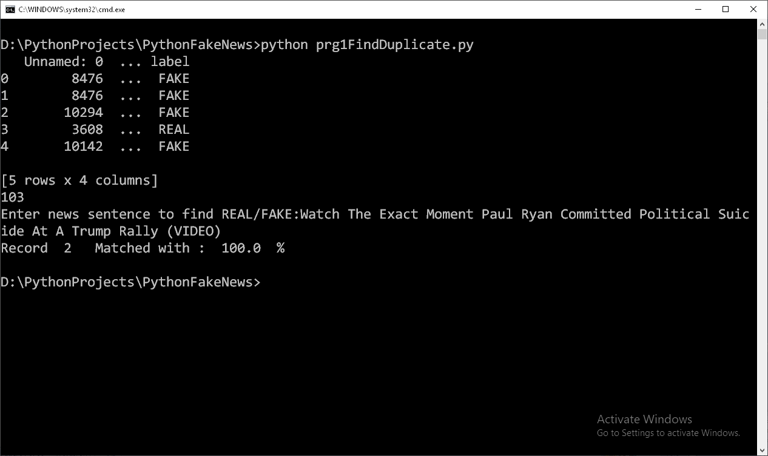
SVM CLASSIFICATION

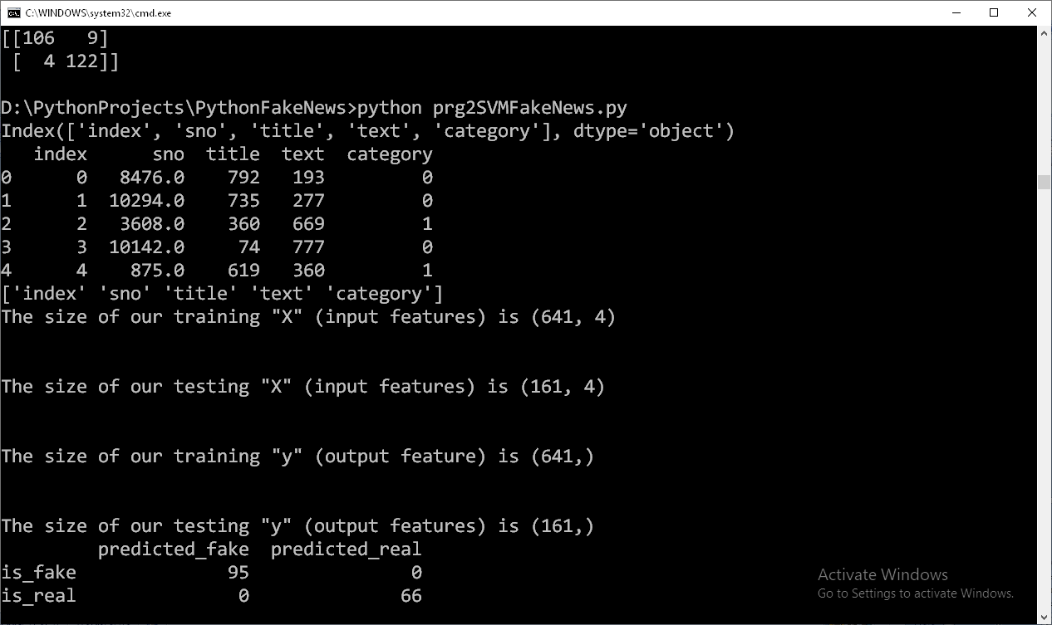
TRAINING SET SIZE
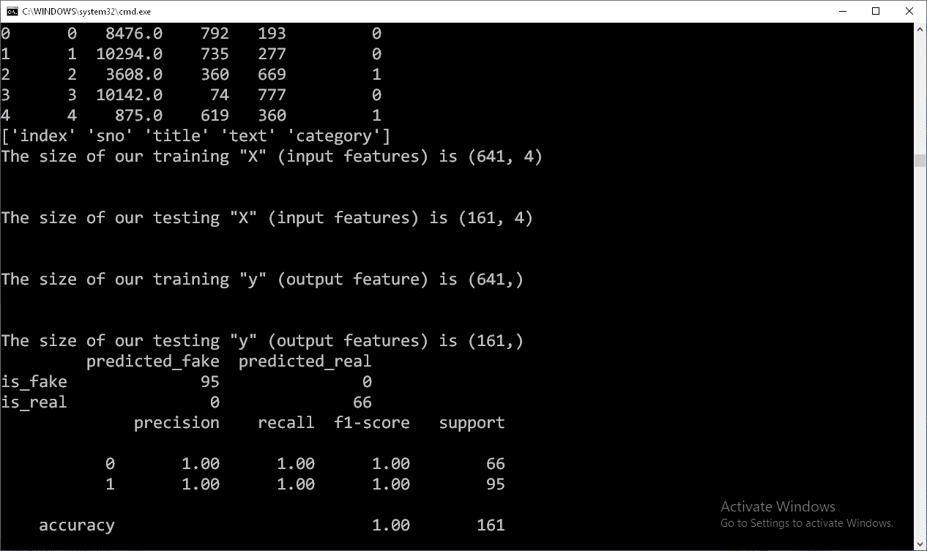
SVM ACCURACY

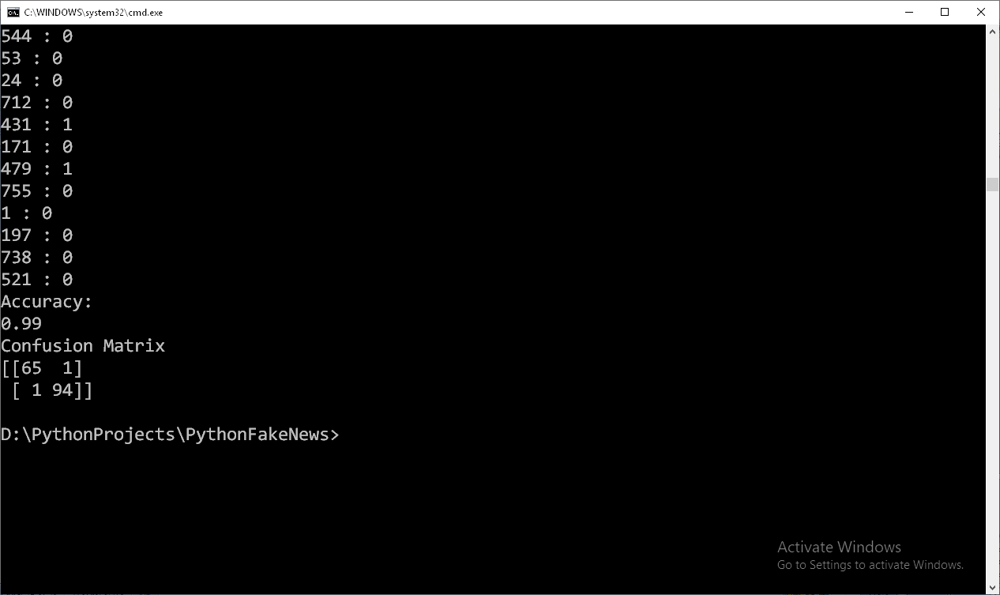
SVM CLASSIFICATION IN GOOGLE COLABS
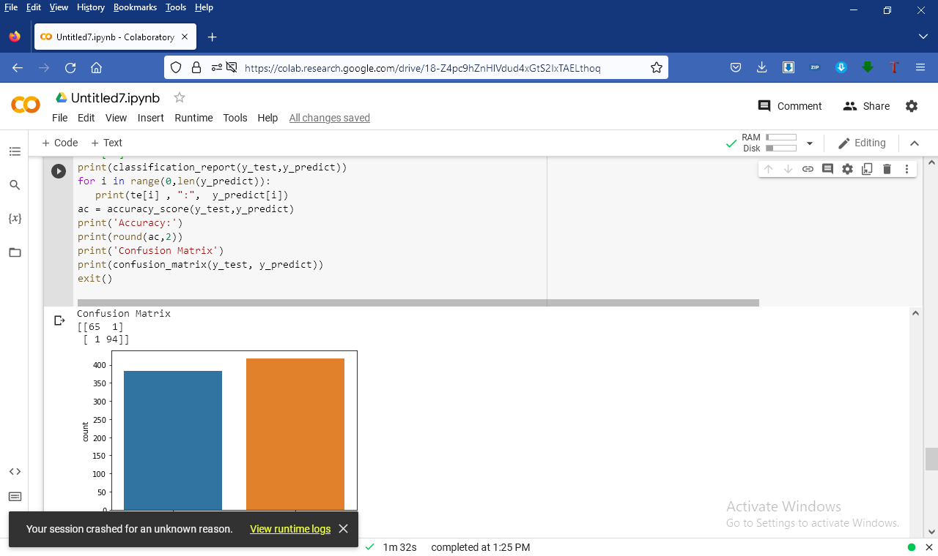
KNN CLASSIFICATION

TRAINING SET SIZE
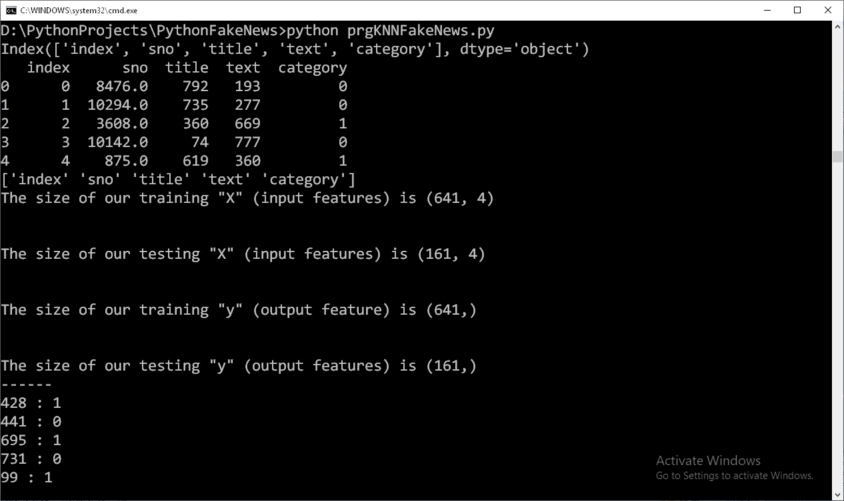
KNN CLASSIFICATION GOOGLE COLABS
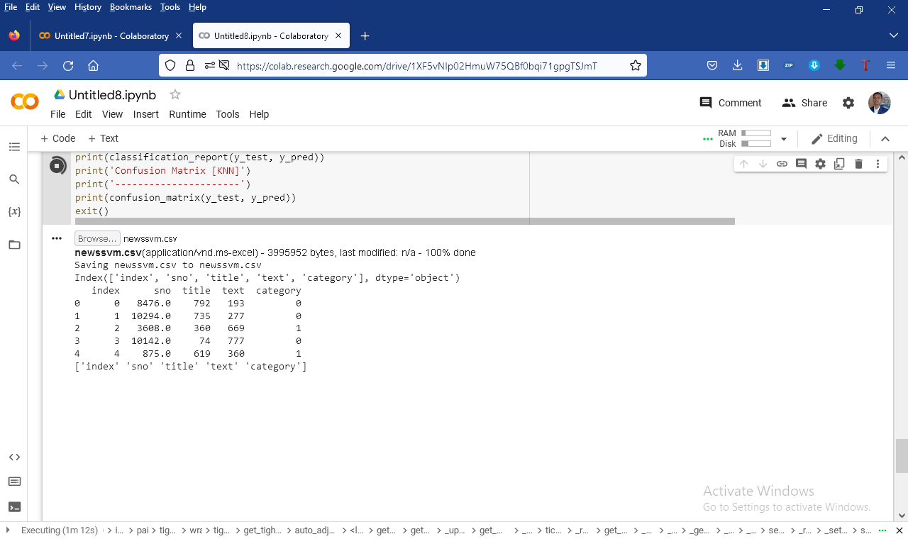

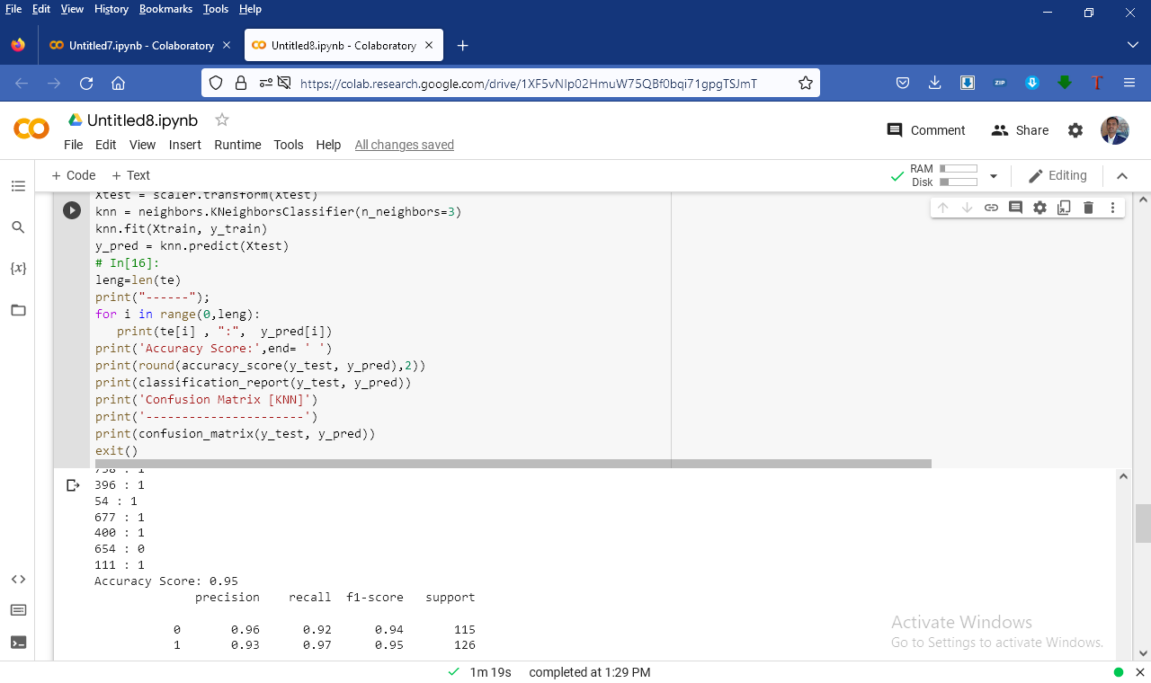
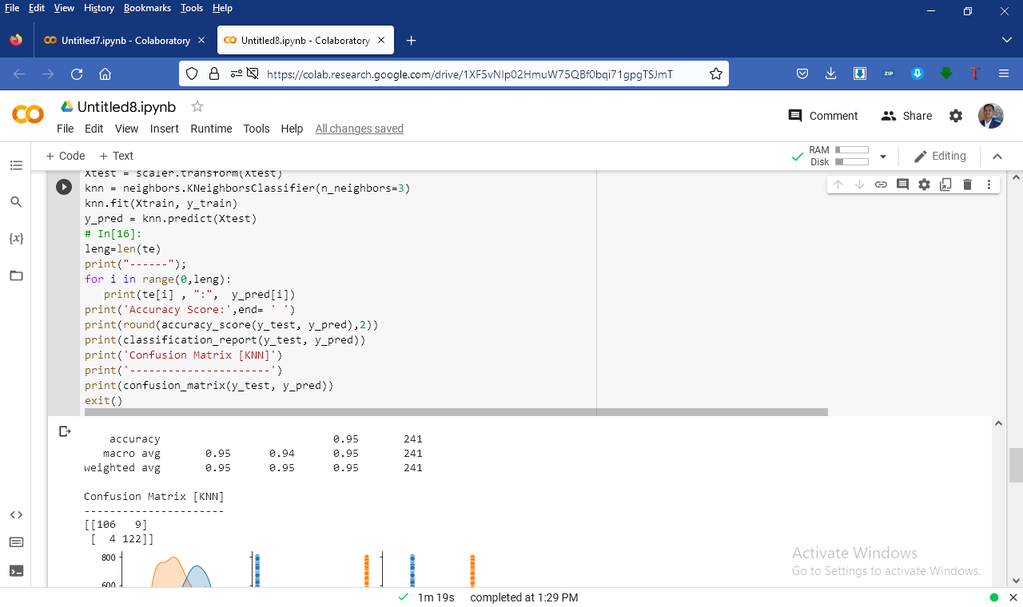
KNN ACCURACY

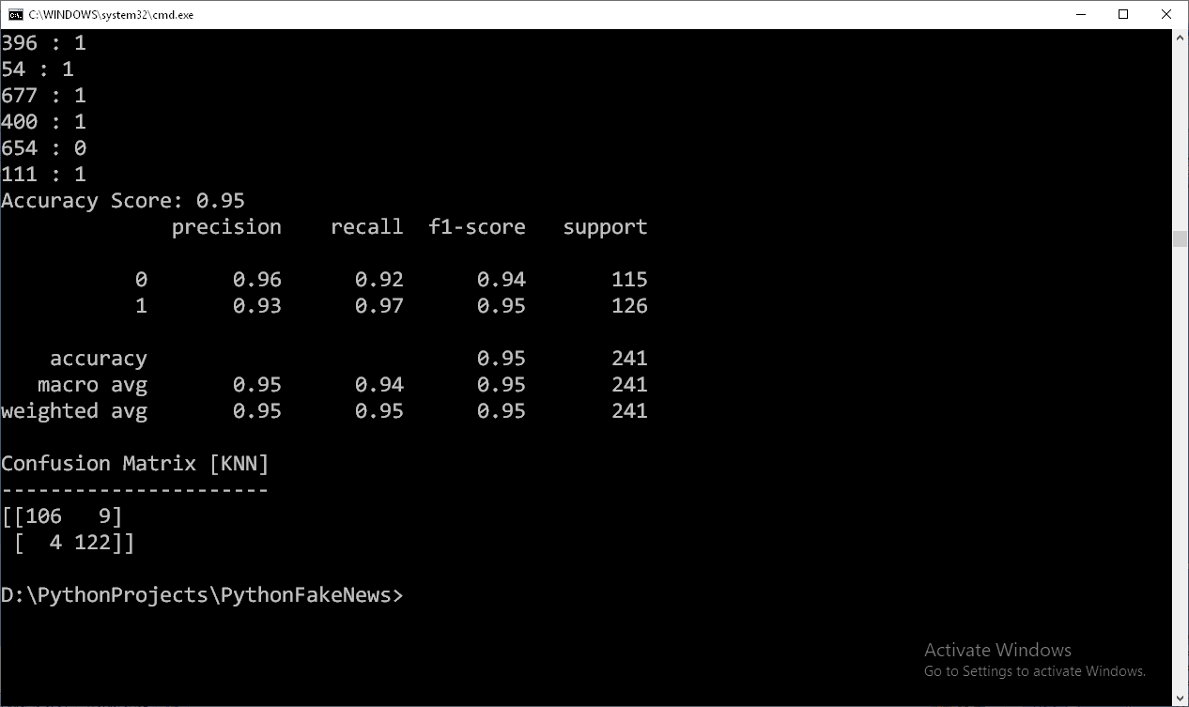

B. SAMPLE CODE

FIND DUPLICATE

import pandas as pd
def strip_non_ascii(string):
''' Returns the string without non ASCII characters'''
stripped = (c for c in string if 0 < ord(c) < 127)
return ''.join(stripped)

# Reading the data
#data = pd.read_csv("news.csv")
#data.head()
df = pd.read_table("news100.csv", delimiter =",")
print(df.head())
rowscount=len(df)
print(rowscount)

print('Enter reviews sentence to find REAL/FAKE REVIEWS:',end='')
newsline=input()
newsline=strip_non_ascii(newsline)
#newsline=(df.iat[2,1])
word=''
wordsnew=[]
for l in newsline.split():
word= l.rstrip(',')
word=word.rstrip('\'')
word= word.lstrip(',')
word=word.rstrip('\'')
word= word.lstrip(':')
word=word.rstrip(':')
word= word.lstrip('\"')
word=word.rstrip('\"')
#print(word,end=' ')
wordsnew.append(word)
line=''
word=''
cnt=0
for i in range(0,rowscount):
#if i>2:
# exit()
line=(df.iat[i,1])
line=strip_non_ascii(line)
words=[]
for l in line.split():
word= l.rstrip(',')
word=word.rstrip('\'')
word= word.lstrip(',')
word=word.rstrip('\'')
word= word.lstrip(':')
word=word.rstrip(':')
word= word.lstrip('\"')
word=word.rstrip('\"')
#print(word,end=' ')
words.append(word)
res = len(set(wordsnew) & set(words)) / float(len(set(wordsnew) | set(words))) * 100
#print(res)
if(res>80):
print('Record ', i , ' Matched with : ', round(res,2) , ' %')
SVM CODING

#!/usr/bin/env python
#python 3.7 32 bit
# coding: utf-8
import pandas as pd
import numpy as np
import matplotlib.pyplot as plt
import seaborn as sns
#get_ipython().run_line_magic('matplotlib', 'inline')
(http://archive.ics.uci.edu/ml/datasets/breast+Fake Reviews+wisconsin+%28diagnostic%29)
#from sklearn.datasets import load_breast_Fake Reviews
data = pd.read_csv("newssvm.csv")
def strip_non_ascii(string):
''' Returns the string without non ASCII characters'''
stripped = (c for c in string if 0 < ord(c) < 127)
return ''.join(stripped)
data.head()
Fake Reviews=data
data['title']=data['title'].str.replace("€", "")
data['title']=data['title'].str.replace("™", "")
data['title']=data['title'].str.replace("â", "")
data['text']=data['text'].str.replace("€", "")
data['text']=data['text'].str.replace("™", "")
data['text']=data['text'].str.replace("â", "")
data['text']=data['text'].str.replace(",", "")
data['title']=data['title'].str.replace(",", "")
data['category']=data['category'].astype('category')
data['title']=data['title'].astype('category')
data['text']=data['text'].astype('category')
data.replace(np.nan,0)
data = data.replace([np.inf, -np.inf], np.nan)
data = data.dropna()
data = data.reset_index()
#newsline=strip_non_ascii(i)
# As we can see above, not much can be done in the current form of the dataset. We need to view the data in a better format.
# # Let's view the data in a dataframe.
# In[3]:
df = data#pd.DataFrame(np.c_[Fake Reviews['title'], Fake Reviews['category']], columns = np.append(Fake Reviews['category'], ['category']))
df.head()
df.shape
# As we can see,we have 596 rows (Instances) and 31 columns(Features)
# In[5]:
print(df.columns)
#df=df.replace(to_replace=None, value=None, inplace=False, limit=None, regex=False, method='pad')
#df['category']=df['category'].astype('category')
#df['title']=df['title'].astype('category')
cat_columns = df.select_dtypes(['category']).columns
cat_columns
df[cat_columns] = df[cat_columns].apply(lambda x: x.cat.codes)
print(df.head())
#exit()
# Above is the name of each columns in our dataframe.
# # The next step is to Visualize our data
# In[6]:
print(df.columns.values)
# Let's plot out just the first 5 variables (features)
#sns.pairplot(df, hue = 'category', vars = ['title', 'category'])
# **Note:**
# In[8]:
df['category'].value_counts()
# As we can see, we have 212 - Malignant, and 357 - Benign
# Let's visulaize our counts
# In[9]:
sns.countplot(df['category'], label = "Count")
# # Let's check the correlation between our features
# In[10]:
plt.figure(figsize=(20,12))
sns.heatmap(df.corr(), annot=True)
X = df.drop(['category'], axis = 1) # We drop our "target" feature and use all the remaining features in our dataframe to train the model.
X.head()
# In[12]:
y = df['category']
y.head()
# # Create the training and testing data
# Now that we've assigned values to our "X" and "y", the next step is to import the python library that will help us to split our dataset into training and testing data.
# - Training data = Is the subset of our data used to train our model.
# - Testing data = Is the subset of our data that the model hasn't seen before. This is used to test the performance of our model.
# In[13]:
from sklearn.model_selection import train_test_split
# Let's split our data using 80% for training and the remaining 20% for testing.
# In[14]:
indices =range(len(df))
leng=len(df)
X_train, X_test, y_train, y_test,tr,te = train_test_split(X, y,indices, test_size = 0.2, random_state = 20)
# Let now check the size our training and testing data.
# In[15]:
print ('The size of our training "X" (input features) is', X_train.shape)
print ('\n')
print ('The size of our testing "X" (input features) is', X_test.shape)
print ('\n')
print ('The size of our training "y" (output feature) is', y_train.shape)
print ('\n')
print ('The size of our testing "y" (output features) is', y_test.shape)
# # Import Support Vector Machine (SVM) Model
# In[16]:
from sklearn.svm import SVC
# In[17]:
svc_model = SVC()
# # Now, let's train our SVM model with our "training" dataset.
# In[18]:
svc_model.fit(X_train, y_train)
# # Let's use our trained model to make a prediction using our testing data
# In[19]:
y_predict = svc_model.predict(X_test)
from sklearn.metrics import classification_report, confusion_matrix,accuracy_score
# In[21]:
cm = np.array(confusion_matrix(y_test, y_predict, labels=[1,0]))
confusion = pd.DataFrame(cm, index=['is_Fake Reviews', 'is_real'],
columns=['predicted_Fake Reviews','predicted_real'])
print(confusion)
# In[22]:
sns.heatmap(confusion, annot=True)
# In[23]:
print(classification_report(y_test, y_predict))
X_train_min = X_train.min()
X_train_min
# In[25]:
X_train_max = X_train.max()
X_train_max
# In[26]:
X_train_range = (X_train_max- X_train_min)
X_train_range
# In[27]:
X_train_scaled = (X_train - X_train_min)/(X_train_range)
X_train_scaled.head()
# # Normalize Training Data
# In[28]:
X_test_min = X_test.min()
X_test_range = (X_test - X_test_min).max()
X_test_scaled = (X_test - X_test_min)/X_test_range
# In[29]:
svc_model = SVC()
svc_model.fit(X_train_scaled, y_train)
# In[30]:
y_predict = svc_model.predict(X_test_scaled)
cm = confusion_matrix(y_test, y_predict)
# # SVM with Normalized data
# In[31]:
cm = np.array(confusion_matrix(y_test, y_predict, labels=[1,0]))
confusion = pd.DataFrame(cm, index=['is_Fake Reviews', 'is_real'],
columns=['predicted_Fake Reviews','predicted_real'])
confusion
# In[32]:
sns.heatmap(confusion,annot=True,fmt="d")
# In[33]:
print(classification_report(y_test,y_predict))
for i in range(0,len(y_predict)):
print(te[i] , ":", y_predict[i])
ac = accuracy_score(y_test,y_predict)
print('Accuracy:')
print(round(ac,2))
print('Confusion Matrix')
print(confusion_matrix(y_test, y_predict))
exit()
KNN CODING
#!/usr/bin/env python
#python 3.7 32 bit
# coding: utf-8
import pandas as pd
import numpy as np
import matplotlib.pyplot as plt
import seaborn as sns
#get_ipython().run_line_magic('matplotlib', 'inline')
#Import Fake reviews data from the Sklearn library
# Dataset can also be found here (http://archive.ics.uci.edu/ml/datasets/breast+Fake Reviews+wisconsin+%28diagnostic%29)
#from sklearn.datasets import load_breast_Fake Reviews
#Fake reviews = load_breast_Fake Reviews()
#from google.colab import files
#uploaded = files.upload()
data = pd.read_csv("newssvm.csv")
data.head()
Fake Reviews=data
data['title']=data['title'].str.replace("€", "")
data['title']=data['title'].str.replace("™", "")
data['title']=data['title'].str.replace("â", "")
data['text']=data['text'].str.replace("€", "")
data['text']=data['text'].str.replace("™", "")
data['text']=data['text'].str.replace("â", "")
data['text']=data['text'].str.replace(",", "")
data['title']=data['title'].str.replace(",", "")
data['category']=data['category'].astype('category')
data['title']=data['title'].astype('category')
data['text']=data['text'].astype('category')
data.replace(np.nan,0)
data = data.replace([np.inf, -np.inf], np.nan)
data = data.dropna()
data = data.reset_index()
# In[2]:
#print(Fake Reviews)
#print(Fake Reviews.columns)
# As we can see above, not much can be done in the current form of the dataset. We need to view the data in a better format.
# # Let's view the data in a dataframe.
# In[3]:
df = data#pd.DataFrame(np.c_[Fake Reviews['title'], Fake Reviews['category']], columns = np.append(Fake Reviews['category'], ['category']))
df.head()
df.shape
# As we can see,we have 596 rows (Instances) and 31 columns(Features)
# In[5]:
print(df.columns)
#df=df.replace(to_replace=None, value=None, inplace=False, limit=None, regex=False, method='pad')
df['category']=df['category'].astype('category')
df['title']=df['title'].astype('category')
cat_columns = df.select_dtypes(['category']).columns
cat_columns
df[cat_columns] = df[cat_columns].apply(lambda x: x.cat.codes)
print(df.head())
#exit()
# Above is the name of each columns in our dataframe.
# # The next step is to Visualize our data
# In[6]:
print(df.columns.values)
# Let's plot out just the first 5 variables (features)
sns.pairplot(df, hue = 'category', vars = ['title', 'category', 'category'])
# **Note:**
#
# 1.0 (Orange) = Benign (No Fake Reviews)
#
# 0.0 (Blue) = Malignant (Fake Reviews)
# # How many Benign and Malignant do we have in our dataset?
# In[8]:
df['category'].value_counts()
# As we can see, we have 212 - Malignant, and 357 - Benign
# Let's visulaize our counts
# In[9]:
sns.countplot(df['category'], label = "Count")
# # Let's check the correlation between our features
# In[10]:
plt.figure(figsize=(20,12))
sns.heatmap(df.corr(), annot=True)
X = df.drop(['category'], axis = 1) # We drop our "target" feature and use all the remaining features in our dataframe to train the model.
X.head()
# In[12]:
y = df['category']
y.head()
# # Create the training and testing data
# Now that we've assigned values to our "X" and "y", the next step is to import the python library that will help us to split our dataset into training and testing data.
# - Training data = Is the subset of our data used to train our model.
# - Testing data = Is the subset of our data that the model hasn't seen before. This is used to test the performance of our model.
# In[13]:
from sklearn.model_selection import train_test_split
# Let's split our data using 80% for training and the remaining 20% for testing.
# In[14]:
indices =range(len(df))
leng=len(df)
X_train, X_test, y_train, y_test,tr,te = train_test_split(X, y,indices, test_size = 0.2, random_state = 20)
# Let now check the size our training and testing data.
# In[15]:
print ('The size of our training "X" (input features) is', X_train.shape)
print ('\n')
print ('The size of our testing "X" (input features) is', X_test.shape)
print ('\n')
print ('The size of our training "y" (output feature) is', y_train.shape)
print ('\n')
print ('The size of our testing "y" (output features) is', y_test.shape)
# # Import Support Vector Machine (SVM) Model
from sklearn import neighbors, datasets, preprocessing
from sklearn.model_selection import train_test_split
from sklearn.metrics import accuracy_score
from sklearn.metrics import classification_report
from sklearn.metrics import confusion_matrix
#iris = datasets.load_iris()
#X, y = iris.data[:, :], iris.target
indices =range(len(df))
Xtrain, Xtest, y_train, y_test,tr,te = train_test_split(X, y, indices,stratify = y, random_state = 0, train_size = 0.7)
scaler = preprocessing.StandardScaler().fit(Xtrain)
Xtrain = scaler.transform(Xtrain)
Xtest = scaler.transform(Xtest)
knn = neighbors.KNeighborsClassifier(n_neighbors=3)
knn.fit(Xtrain, y_train)
y_pred = knn.predict(Xtest)
# In[16]:
leng=len(te)
print("------");
for i in range(0,leng):
print(te[i] , ":", y_pred[i])
print('Accuracy Score:',end= ' ')
print(round(accuracy_score(y_test, y_pred),2))
print(classification_report(y_test, y_pred))
print('Confusion Matrix [KNN]')
print('----------------------')
print(confusion_matrix(y_test, y_pred))
exit()

